COURSE SYLLABUS

Course: MAN 3353 Management Theory and Practices
Campus: West
Semester/Term: Fall 2018
Prerequisites: None
Credit Hours: 3
Class Meeting Day/Time: Online
Classroom: Online

Professor: Devika Ramsingh
Email: dramsingh1@valenciacollege.edu
Office Phone: 407-582-1536
Office: WC06-326H
Office Hours: The best way to contact me is by email to schedule a phone call or in-person appointment.

Course Description:
This course is a study of basic concepts and theories of management. The functional roles and processes for planning, leading, organizing, and controlling are emphasized. Other topics covered include, but are not limited to, team development, leadership, strategic development, decision making, ethics, diversity, and globalization.

Course Major Learning Outcomes:
Students will be able to:
- Describe and discuss the element of effective management.
- Identify environmental issues that impact management and develop strategies to adapt to these environments.
- Identify and explain issues involved in managing a diverse workforce and conduct necessary research to address these issues.
- Discuss and apply the planning, organizing, and control processes.
- Identify and discuss various theories related to the development of leadership skills, motivation techniques, teamwork, and effective communication.
- Identify and understand ethical and social responsibility issues.
- Understand issues related to organizational control.
- Identify and apply management theories to organizations.

Required Text:
The Open Educational Resources (OER) used for the duration of this course (No Textbook Fee) Courtesy of Open Texts books.
Exploring Business: https://open.umn.edu/opentextbooks/BookDetail.aspx?bookId=15

Course Organization:
This course will be divided into four categories that will comprise the final grade.

Discussion 20%
Exercises 25%
Exams/Quizzes 30%
Program Portfolio Project 25%
100%

General Grading Scale:
A: 90-100
B: 80-89
C: 70-79
D: 60-69
F: 60-below

CLASSROOM POLICIES
Assignments

Discussion Instructions (Initial Post is Require before “Viewing” Peer Posts): You are required to submit a substantial response. A substantial response is one that stays on topic and fully addresses the assignment in a clear, concise, and meaningful manner. Substantial Content refers to providing relevant content toward the actual topic of the discussions. This includes quality input, questions and information in your discussion posts and responses to peers.

The deliverable length of initial posting must be at least 100 words. After the initial posting, students are required to respond to at least two (2) peers’ responses. Peer responses must be at least 50 words for each response, in order to receive full credit. Discussions must be the student’s original thoughts based on the topics from the "Open Educational Resource" (OER) Course Textbook and/or other referenced sources. Direct quotes from references must be less than 10 words. Plagiarized discussions will result in a "0" for the submission of this assignment. Please review postings for sentence structure, grammar and punctuation errors. Late submissions are not accepted for discussions.

Discussion Posting Rules

- Personal attacks of other students because of their posts will not be tolerated.
- Provide clear analysis and insight into the topic or questions.
- Post original thoughts to avoid plagiarism and the penalties for plagiarism
- Zero or minimal credit will be given to students with very FEW or NO SUBSTANTIVE postings or who post all posts with in a matter of minutes or all on the last day.
- Proof postings to eliminate offensive references, poor sentence syntax, misspelled words, etc.

Exercise Instructions: You are required to submit a 2-Page (Title Page and Content Page), APA formatted paper with substantial content. Substantial content requires staying on topic and fully addresses the assignment in a clear, concise, and meaningful manner. The deliverable length of your posting responses must be at least 2-pages, (Title Page and Content Page) APA format. Please review your paper for grammar and punctuation errors.

Exercises must be the student’s original thoughts based on the topics from the "Open Educational Resource" (OER) Course Textbook and/or other referenced sources. Direct quotes from references must be less than 20 words. Plagiarized exercises may result in a "0" for the submission of this assignment. Please review postings for sentence structure, grammar and punctuation errors. Late submissions will be deducted 5 points.

Exam Instructions: Mid-Term/Final Exam contains “critical thinking” randomly selected essay questions. Students will be instructed in and will apply critical thinking skills to include creative thinking, innovation, inquiry, analysis, evaluation, and synthesis of information. Students will be instructed in and will apply knowledge, skills and ability to include development, interpretation, and expression of ideas through written communication.

Students will have 1 attempt to complete the exam with the duration of 150 minutes to complete the exam. Students must complete the entire exam in the attempt (If the exam or the web browsers is closed - the exam is considered completed). The exam consists of 10 randomly selected essay questions based on the related chapter(s) learning objectives of each module covered thus far.

Students are required to read and fully answer the essay questions in order to receive full points. Students are required to submit a substantial response to each essay question. A substantial response is one that stays on topic and fully addresses the essay question in a clear, concise, and meaningful manner. Some essay questions required the student to provide examples to support the essay question being answered. The deliverable length of answer must be at least 50 words. Please review your answers for grammar and punctuation errors.

Program Portfolio (Capstone) Project Overview

The student will develop, create and present a business proposal during the capstone course. Students may use a current business; a business the student wants to create or a fictitious business organization. The important key is for the student to critically think and research the business which will be used to develop a business plan in its entirety. The student will need to think about all the facets of a business for the duration of the Program Portfolio (Capstone) Project.

Each BAS course is an active part of students developing, creating and completing a segment of the Program Portfolio (Capstone) Project. The BAS Program courses learning objectives all align with students developing, creating and completing the Program Portfolio (Capstone) Project. Students will apply the knowledge, skills and abilities learned from each BAS Program course(s) toward the development, creation and completion of the Program Portfolio Project.

Each BASBOL upper level core (3000 and 4000) courses will have a different topic of the Program Portfolio Project. Students are to submit original content for each BASBOL upper level core (3000 and 4000) course. Students will work on for their final submission during the capstone. Students will have access to this course project paper in the last module. For more information, contact your professor.

Program Portfolio (Capstone) Project - Course MAN 3353: Create the basic concepts and theories of management for your business. You should include functional roles and processes for planning, leading, organizing, and controlling. Research examples to support the development of your Program Portfolio Project business organizational overview.

You are required to submit a 3-Page (Title Page and 2 Pages of Content), APA formatted paper with substantial content. Substantial content requires staying on topic and fully addresses the assignment in a clear, concise, and meaningful manner. The deliverable length of your posting responses must be at least 3-page (Title Page and 2 Pages of Content), APA format. Please review your paper for grammar and punctuation errors.

Submission must be the student’s original thoughts based on the topics from the "Open Educational Resource" (OER) Course Textbook and/or other referenced sources. Direct quotes from references must be less than 20 words. Plagiarized submissions may result in a "0" for the submission of this assignment. Please review for sentence structure, grammar and punctuation errors. Late submissions will be deducted 10 points.

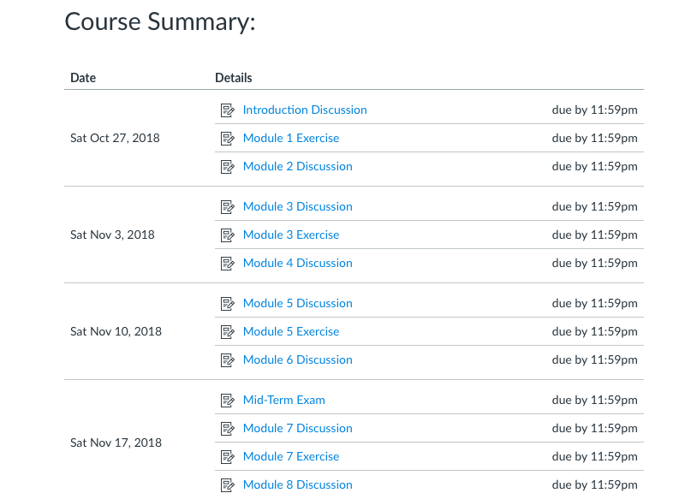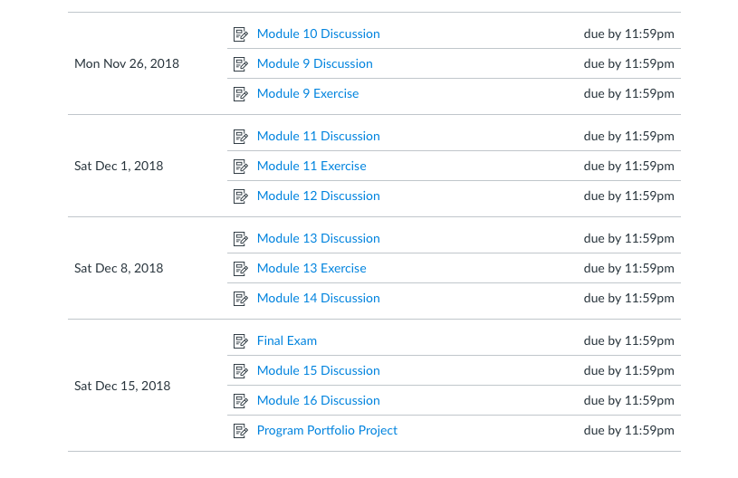

Make-up Exams:
Make-up exams will only be given in emergency situations provided the instructor is notified in advance (prior to the absence). Upon approval of your absence, the exam will be placed in the testing center. Exams must be made up before the next class meeting. Any test missed will have an adverse effect on your grade, and make-up test will not be given unless approved by the professor prior to the date of the scheduled test. Proof of absence is required for make-up exams.

Homework and Quizzes:
If a student is absent, it is his/her responsibility to contact a class member, obtain the assignment and come to the next class meeting prepared. If a student is absent the day of a quiz, they will receive a zero. See “Assignments” for late submission information.

Expected Student Conduct:
Valencia College is dedicated, not only to the advancement of knowledge and learning, but is concerned with the development of responsible personal and social conduct. By enrolling at Valencia College, a student assumes the responsibility of becoming familiar with and abiding by the general rules of conduct. The primary responsibility for managing the classroom environment rests with the faculty. Students who engage in any prohibited or unlawful acts that result in disruption of a classroom or Valencia’s rules may lead to disciplinary action up to and including expulsion from Valencia. Disciplinary action could include; being withdrawn from class, disciplinary warning, probation, suspension, expulsion or other appropriate and authorized actions. You will find the student code of conduct in the current Policy & Procedures Manual at http://www.valenciacollege.edu/generalcounsel/.

Attendance:
Punctual and regular attendance is mandatory in this course. Students are responsible for all material covered in class. Valencia’s attendance policy is that a student will be present for all class meetings.

No show withdrawal: Valencia policy is that any student that does not come to class during our first two meetings will be withdrawn. The policy can be located at the following link: http://catalog.valenciacollege.edu/academicpoliciesprocedures/classattendance
Valencia College students are held accountable for meeting all course requirements. Students must therefore realize that they are expected to attend all regularly scheduled meetings of courses in which they are enrolled. Professors will record attendance during each class session. The student is expected to carry out all assigned work and to take examinations at the class period designated by the instructor. Failure to carry out these assignments or to take examinations at the designated times may result in an appropriate reduction in grade or being dropped from the course.

Three partial attendances count as an absence. A partial attendance is defined as arriving tardy, leaving early, or not being an active participant in the class session. Leaving after a test counts as two partial attendances. There are no excused absences from this class. I reserve the right to withdraw or fail a student who has 4 or more absences or any combination of partial attendances and absences equaling 4 absences. Students missing the first-class session are subject to withdrawal as “no shows.”

For Online Attendance

For online attendance, students are required to log on weekly, review the week's course material and submit appropriate assignments/exams. Individual Assignments or Internet Assignments are due for each module of the online course. Attendance will be taken based on your submitting assignments weekly. If a student fails to submit an assignment when due, the student will be marked absent for that week.

Procedures for Reporting Absences

It is the responsibility of the student, where possible, to notify instructors regarding absences for whatever reason or period of time. This should take place before leaving campus, during an illness or upon return to campus.
For more information on Valencia College “Attendance Policy” Click Here:
http://catalog.valenciacollege.edu/academicpoliciesprocedures/classattendance/

0-2 absences = 100% for the attendance grade
3-3+ absences = 0% for the attendance grade, resulting in a reduction of one letter grade
4+ absences = 0% for attendance, resulting in possible withdraw or an F in the course

Two partial attendances are counted as an absence; e.g. two tardy days equals one absence. A partial attendance is defined as arriving tardy, leaving early, or not being an active participant in the class session. Leaving after a test is counted as full absence. There are no excused absences from my class. I reserve the right to withdraw or fail a student due to excessive absences, normally viewed as 4 or more.

Email Policy:
Students must have an active Atlas account. Students must check their Atlas e-mails regularly as to not miss any important messages from the professor. Missed messages via Atlas or any other medium (in-class, etc.) may affect your grade and are the responsibility of the student.

Academic Honesty:
Each student is expected to do his or her own work, unless otherwise specified. Cheating will not be tolerated and will result in an automatic “zero” on that exam or assignment. For obvious reasons, cell phones will not be permitted to be used as calculators or for any other reasons during exams. Anyone accessing their phone during an exam will receive an automatic zero for that exam. Students may not leave the classroom for any reason during exams.

Student Technology in the Classroom:
I understand there are many good reasons to have laptops, mobile phones, and other wireless communication devices. Many of us have work and family responsibilities that sometimes cannot wait until the end of class.

Recognizing that it may be necessary on occasion to communicate with others during class, please do not text, email, surf, talk, or anything else while class is in session. Feel free to leave the classroom for a moment to take care of any necessary communications. If I find you are “surfing the web” and are not engaged in the class, I may ask you to put your electronic device away for the remainder of the class session and/or semester.

Florida is a “two consent” state concerning recording conversations. Students may not record their instructors, either in conversation or in class, without their consent. If you want to record a classroom conversation, you must first receive permission from everyone in the room.

Academic Accommodations:
“Students with disabilities who qualify for academic accommodations must provide a Notification to Instructor (NTI) form from the Office for Students with Disabilities (OSD) and discuss specific needs with the professor, preferably during the first two weeks of class. The Office for Students with Disabilities determines accommodations based on appropriate documentation of disabilities. See the appropriate office for more information:
- East Campus Bldg. 5, Rm. 216 Ph: 407-582-2229 Fax: 407-582-8908 TTY: 407-582-1222
- West Campus SSB, Rm. 102 Ph: 407-582-1523 Fax: 407-582-1326 TTY: 407-582-1222
- Osceola Campus Bldg. 1, Rm. 140A Ph: 407-582-4167 Fax: 407-582-4804 TTY: 407-582-1222
- Winter Park Campus Bldg. 1, Rm. 212 Ph: 407-582-6887 Fax: 407-582-6841 TTY: 407-582-1222

Student Assistance Program:
Valencia College is interested in making sure all our students have a rewarding and successful college experience. To that purpose, Valencia students can get immediate help with issues dealing with stress, anxiety, depression, adjustment difficulties, substance abuse, time management as well as relationship problems dealing with school, home or work. BayCare Behavioral Health Student Assistance program (SAP) services are free to all Valencia students and available 24 hours a day by calling (800) 878-5470. This number is also located on the back of your Valencia Student ID. Free face to face counseling is also available.

Withdrawal Policy:
The withdrawal policy deadline for the semester – See Academic Calendar “Important Dates & Deadlines” http://valenciacollege.edu/calendar/

A student who withdraws from class before the established deadline for a particular term will receive a grade of “W”. A student is not permitted to withdraw after the withdrawal deadline. After this date, the grade assigned will be based on the student’s academic achievement in class and the actual work completed.

Institutional Core Competencies:
The following Valencia Student Competencies will be reinforced throughout the entire course:
- THINK – Analyze data, ideas, patterns, principles, and perspectives employing facts, formulas and procedures of the discipline.
- VALUE – Distinguish among personal, ethical, aesthetic, cultural, and scientific values evaluating your own and others values from a global perspective in the process of learning the discipline.
- COMMUNICATE – Identify your own strengths and need for improvement as a communicator employing methods of communication appropriate to your audience and purposefully evaluate the effectiveness of your own and others communication.
- ACT – Apply disciplinary knowledge, skills, and values to educational and career goals acting effectively and appropriately in various personal and professional settings responding also to changing circumstances.

Disclaimer:
Changes in this syllabus, schedule, and or college policy may be made at any time during the course per instructor discretion. Students are responsible for staying abreast of these changes.

